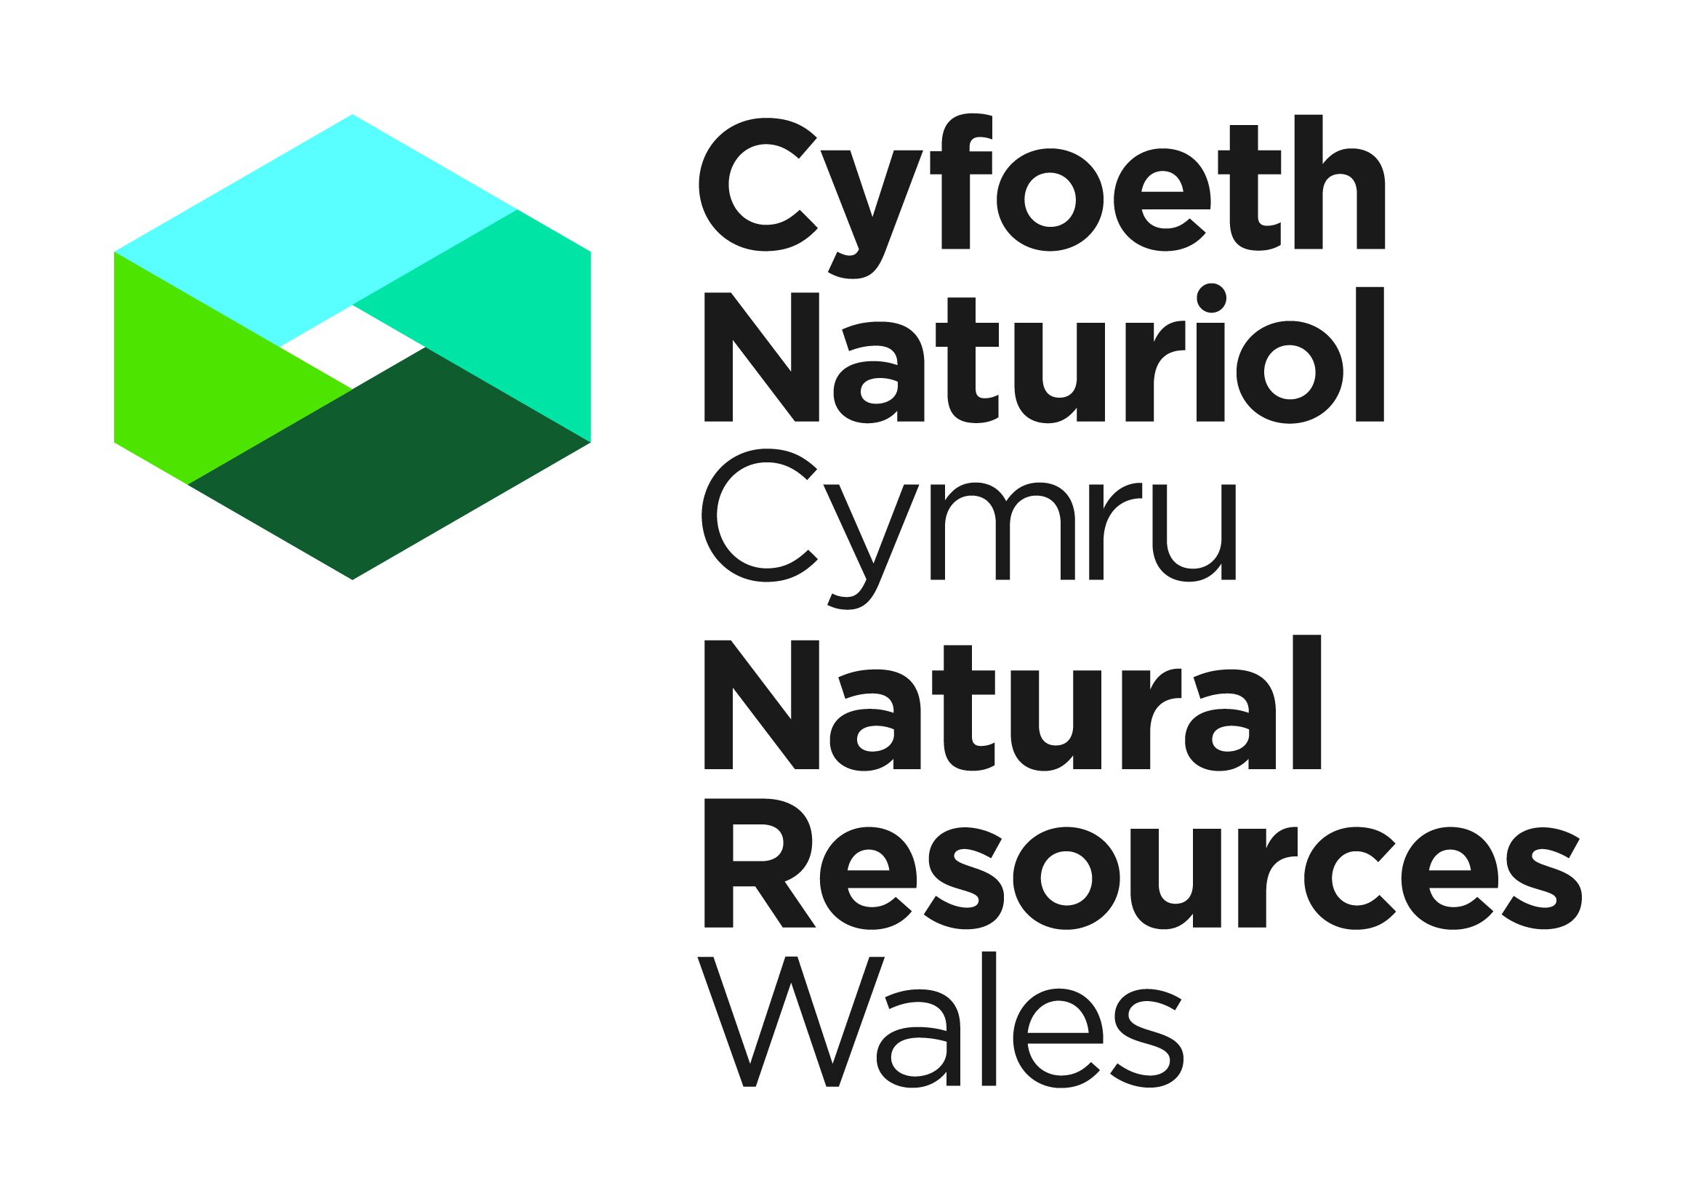


Application for a Licence - Possession of Annex IV Species of the Habitats Directive

The Conservation of Habitats and Species Regulations 2017

Applicants should complete all parts of this application form and refer to the supporting notes on the back of this form prior to completion.

All questions relate to the person who will be the named licensee if a licence is granted under the Habitats and Species Regulations 2017. That person should complete and sign this form. Please complete in BLOCK CAPITALS (* delete as applicable)

1. The Applicant: Personal details
These questions relate to the person who will be the named licence holder. As the licensee you will be responsible for ensuring compliance with the licence and its conditions.
1. (a) Name of applicant
Title (Mr/Mrs/Miss/Ms) |  | Forename(s) |  | Surname

Business Title (if appropriate)
(b) Address to where the licence is to be sent
 |  |  |  | Town
 |  |  |  | County |  |  |  |  |  |  | Postcode
Tel number (incl. national dialling code)
Mobile number
Email address
(c) Address where specimens are to
be held (if different from above)
 |  |  |  | Town
 |  |  |  | County |  |  |  |  |  |  | Postcode
 | 2. |  | Previous licences
 |  |  | Have you previously held a licence authorising the possession of a specimen of European protected species issued by The Welsh Government or NRW. |  |  |  |  |  |  |  |  | YES/NO
 |  |  | If YES, please give your last licence number and the year in which the licence was issued.
 |  |  | Licence number |  |  |  |  |  | Year issued
 |  |  | What species were covered by the licence?
 | Have you ever been convicted of a wildlife offence? YES/NO
If ‘YES’, give details.

3. Species details
- if you wish to apply for more than the limits set down in table 3a, then please specify the total numbers you wish to possess in the right hand column of table 3a.
- if you wish to apply for possession of other species please complete table 3b.

3a. General limits for certain species/groups
Species/group | Number of specimens | Rationale | Place an x in the area of possession you wish to apply for. | If greater numbers than listed, then please specify exact number
Bats  (All Annex IV) | 25 dead | Specimens widely used for identification training and education
Bats  (All Annex IV) | 10 live | Long term captives used for identification training and education
Bats  (All Annex IV) | 5 live | For rabies testing
Dormouse | 5 dead | Educational specimens
Lizard, sand | 5 dead | Educational specimens
Newt, great crested | 10 dead | Educational specimens, wide distribution
Otter | 2 dead | Scientific, research specimens
Snake, smooth | 5 dead | Educational specimens
Toad, natterjack | 5 dead | Educational specimens

Please explain how you have obtained or expect to obtain the material within the above limits. E.g. through licensed survey work.

Note:
- it is in your interests to ensure you have appropriate documentary evidence on the material you hold. E.g. who, what, where, when and why.
- this application will be for the life of the licence and cover possession up to the above limits at any one time.

3b. Please tell us about the Annex IV protected species specimen(s) you wish to possess. Please see guidance for possession, transport, sale and exchange of annex IV species issued for Wales
Species  (common name) |  | Scientific name |  | Whole | Part/Derivative |  | Number |  | Please provide if available full details as to how and when the specimen was taken from the wild (e.g. was picked up as a road kill) if it is alive or dead and how it came into your possession. Please provide details of Article 10 CITES certificate if the animal was purchased from an A10 holder.
e.g. Harbour Porpoise |  | Phocoena phocoena |  | No | Yes - skull |  | 3

 | Part D. The Application. This section is to be completed by all applicants.
 | 4. | Purpose of the Licence
Please place an x one box to indicate the primary purpose for the possession of the material.

Possession for scientific purposes
Possession for educational purposes
Possession for conserving wild animals or wild plants or introducing them into particular areas
Possession under strictly supervised conditions, on a selective basis and to a limited extent (for a purpose not included above).

 | 5. | Please provide a written justification in support of your selection in Question 4.
 | 6. | Satisfactory Alternatives
 |  | In order to grant a licence we must be satisfied that there is no satisfactory alternative to the keeping of the specimens. Please provide details of the alternatives that have been considered and the reasons why they have been discounted (i.e. Why do you need to possess and retain the specimen(s)?).
PART C Declaration

WARNING: NRW can modify or revoke any licence that may be issued but this will not be done without good reason. Any licence that is issued is likely to be revoked immediately if it is discovered that false or incorrect information had been provided on this form or any enclosures that resulted in the issue of a licence.

Under the Conservation of Habitats and Species Regulations 2017, any person who in order to obtain a licence knowingly or recklessly makes a statement or representation, or furnishes a document or information which is false in a material particular, shall be guilty of an offence and may be liable to criminal prosecution. Any person found guilty of such offences is liable on summary conviction to imprisonment for a term not exceeding six months or to a fine not exceeding level 5 on the standard scale (currently £5,000), or to both.

I understand that failure to comply with any conditions included on any licence granted in respect of this application may constitute an offence
I have read the notes for guidance on the rear of this form
I declare that the particulars given in this application and accompanying documents are correct to the best of my knowledge and belief, and I apply for a licence in accordance with these particulars
If a licence is granted I agree to send to NRW a written report of the licensed activities within four weeks of the expiry of the licence

Signature |  | Date
For electronic applications please insert an electronic signature above or place an x in the box opposite to confirm agreement with the declarations above.

NAME IN BLOCK LETTERS

Species Permitting Team, Natural Resources Wales, Maes y Ffynnon, Penrhosgarnedd,
Bangor, LL57 2DW or e-mail your completed form to specieslicence@naturalresourceswales.gov.uk
Tel. 03000653000

NOTES FOR GUIDENCE (Please read the following notes carefully).

- This is a licence to possess of Annex IV Species of the Habitats Directive. Licences can be granted allowing people to carry out activities, which would otherwise be illegal. Applicants must be able to demonstrate that they have a suitable amount of expertise to achieve the objectives of the proposed work.
- This application is for permanent possession only. If you wish to undertake the sale or exchange of European protected species you must apply using the appropriate application form.
- When material is temporarily possessed as part of other licensed works such as licensed survey work then this should be applied for under that activity.
- If you wish to temporarily possess already licensed material for < 30days consult the existing licence holder for information.
- A licence is not needed to possess a protected species for the purpose of tending it in order to release it back into the wild. If it turns out that release is not possible, for example because that animal would not survive on its own, and the animal needs to be kept permanently in captivity, a licence is required. Please see guidance for further information and advice relating to the tending of injured /disabled animals.
- General Licences allow the possession of dead European protected species by museums, universities and, research establishments and by members of the Guild of Taxidermists. Dead bats can also be submitted to the VLA for rabies testing under General Licence.
- NRW, in exercise of the powers conferred under the Conservation of Habitats and Species Regulations 2017, have authority to issue licences for possession for the following purposes:

(i) Scientific purposes
(ii) Educational purposes
(iii) Conserving wild animals or wild plants or introducing them to particular areas
  - Possession under strictly supervised conditions, on a selective basis and to a limited extent.
Provided that:
- that there is no satisfactory alternative; and
that the action authorised will not be detrimental to the maintenance of the population of the species concerned at a favourable conservation status in their natural range.

- All questions in this application form must be completed in full unless otherwise stated: failure to provide
adequate information will delay the processing of your application. Any further information you wish to provide should be appended on additional sheets. We aim to process applications within 30 working days of receipt of all the information requested. We cannot guarantee an earlier response.

- Renewal of a licence, including any alterations to species, locations or activities may be requested by completing a renewal application form.

Continued on next page
- Information from applications and licences is required to provide summary information to Natural Resources Wales (NRW)and others on the number of licences issued, the purpose of the licence and which species are covered. None of these summary statistics include personal information about licensees. The information may also be used for conservation purposes and shared with other organisations.

- The information provided by you will be processed by Natural Resources Wales in line with the GDPRs Data Protection Principles. This will to enable us to process your application; to monitor compliance with any permit conditions; to process renewals, and to maintain the relevant public register.

We will process the information you provide in connection with the following:
- Consultation with third parties who are relevant and responsible for responding to consultation requests from NRW to enable us to process your application
- Carrying out statistical analysis, research and development on environmental issues
- Providing public register information for enquiries
- Preventing and investigating possible breaches of environmental law and taking any resulting action
- Responding to requests for information under the Freedom of Information Act 2000 and the Environmental Information Regulations 2004
We would also like to send you details about other topics we think may be of interest to you such as NRW news; services relating to environmental matters; asking for your feedback on our service; and more useful information.

If you consent to receiving further information from us, please tick the following box to confirm
Yes, I would like to receive additional information from NRW relating to environmental matters □
Please note we may pass the information on to our agents or representatives to carry this out for us

If you have any further queries or concerns, please contact dataprotection@naturalresourceswales.gov.uk. For further information on the processing of your personal details please see our Privacy Notice page

xii. Any information included in this application which the applicant considers to be in confidence for commercial or industrial reasons or to be the applicant’s intellectual property must be clearly marked as such.

In this document “Natural Resources Wales” means the Natural Resources Body for Wales established by article 3 of the Natural Resources Body for Wales (Establishment) Order 2012. The Natural Resources Body for Wales (Functions) Order 2013 transferred the relevant functions of the Countryside Council for Wales, and functions of the Environment Agency and the Forestry Commission in Wales to the Natural Resources Body for Wales.

